Реализуйте **RESTful-destroy** по технологии **ajax** (!с **ajax**-обновлением страницы):

…для удаления **alex -> Hi-hi**:

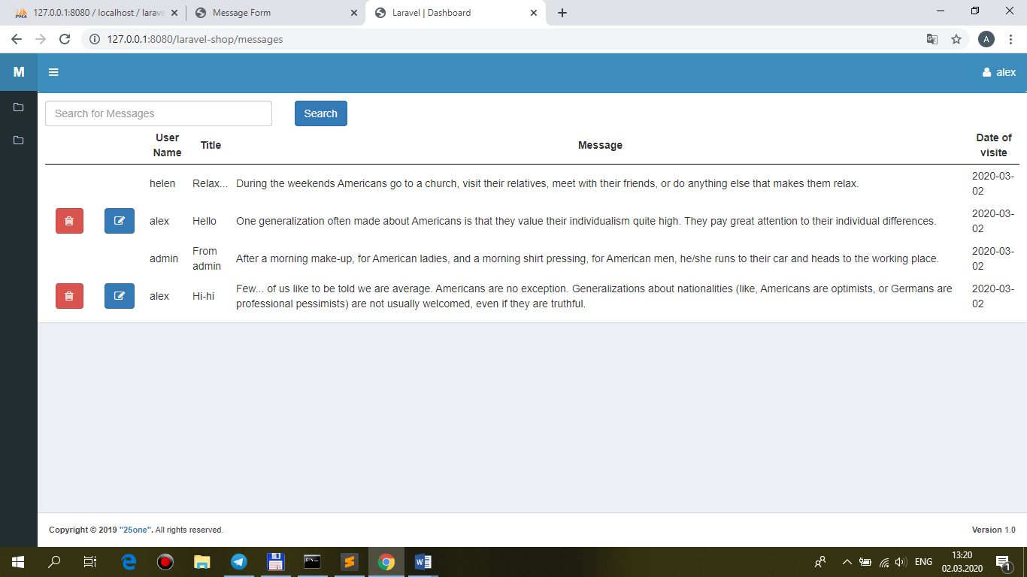

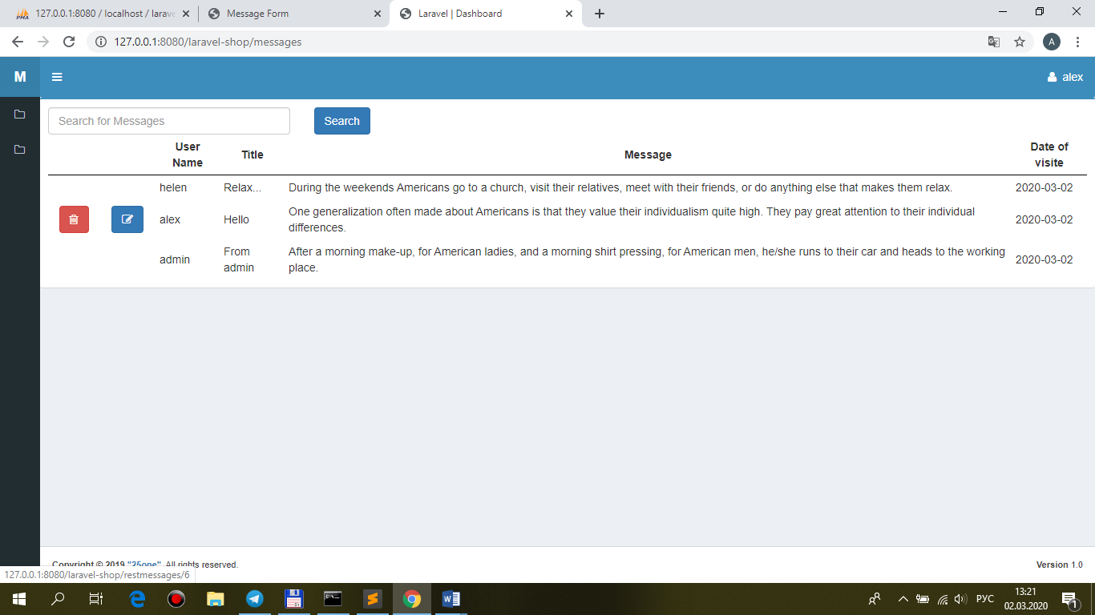

**views\front\messages\brick-standard.blade.php**

@foreach($messages as $message)

<tr>

@if($message->user_id == auth()->user()->id)

<td class="center widthbutton"><a class="btn btn-danger **listbuttonremove**" **href="{{ 'restmessages/' . $message->id}}"**><i class="fa fa-trash-o" aria-hidden="true"></i></a></td>

…

**views\front\messages\index.blade.php**

…

@section('js')

<script src="{{ asset('public/js/main.js') }}"></script>

<script>

$(document).ready(function(){

$('.search_button').click(function(){

BaseRecord.searchMessages($('.search_text').val());

});

**$('.listbuttonremove').click(function(){**

**BaseRecord.destroyMessage($(this).attr('href'));**

**return false;**

**});**

});

</script>

@endsection

**public\js\main.js**

**destroyMessage: function(url){**

//alert(value);

var ajaxSetting={

**method: 'delete',**

**url: url,**

//data: {

// email: email,

//},

**success: function(data){**

//alert(data);

**BaseRecord.dashboardMessages(); //!!!ajax-return to messages**

},

};

$.ajax(ajaxSetting);

},

…

**dashboardMessages: function(){**

//alert(value);

var ajaxSetting={

**method: 'get',**

**url: './messages', //!!!url**

//data: {

// id: id,

//},

**success: function(data){**

//alert(data.table);

**$('#pannel').html(data.table); //!!!.back-pannel**

**$('.listbuttonremove').click(function(){**

**BaseRecord.destroyMessage($(this).attr('href'));**

**return false;**

**});**

},

};

$.ajax(ajaxSetting);

},

**MessageController.php**

/**

* Remove the message from storage.

*

* @param \App\Models\Apimessage $message

* @return \Illuminate\Http\Response

*/

public function **destroy(Apimessage $restmessage)**

**{**

**$this->authorize('manage', $restmessage);**

**$restmessage->delete();**

**return response()->json();**

}